

**Project No. 2019-1-DE02-KA202-006099**



mes Training Curriculums

INDI4.0 Project Stuttgart | 06/2021 Workshop documents Intellectual Output “IO1”

Manufacturing Execution System

with Siemens TIA Porta

OPC-UA Client Server

**UE4 - implementation of the MES <-> PLC interface**

contents

4th Communication flow 4

4.1 Communication instructions 4

4.2 Communication interface 4

A notice:

Solutions or information on the structure of the UE (blackboard, etc.) formatted as "hidden text"

************************************************** **************************************

In the previous lesson, the variables for the MES <-> PLC communication were created and tested. In the following, the implementation of the coordination of the communication process is to be worked out and implemented.

Below you can see the communication scheme for data exchange between PLC <-> MES. The data stored in the MES are entered and / or read out in the structure in a data block through the OPC UA connection. This (board) picture is to be developed together with the students according to their ideas. The following question could serve as an introduction.

**Question:**

**Why does the module have / needs the iCMD input for communication between the PLC <-> MES?**

Solution:

The iCMD variable is required so that the data exchange can be coordinated (controlled). reason

this is because the actual variables do not contain any information about the communication process, but rather

are pure "production data". But so that the communication partners know what to do, the new

Variable iCMD to be introduced.

Result:

The structure TProcessData must be extended by the variable iCMD for the communication between PLC <-> MES

become. The new TMES structure is "developed" from this

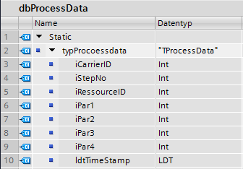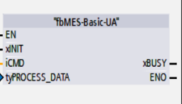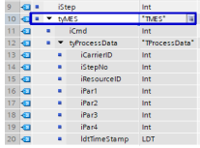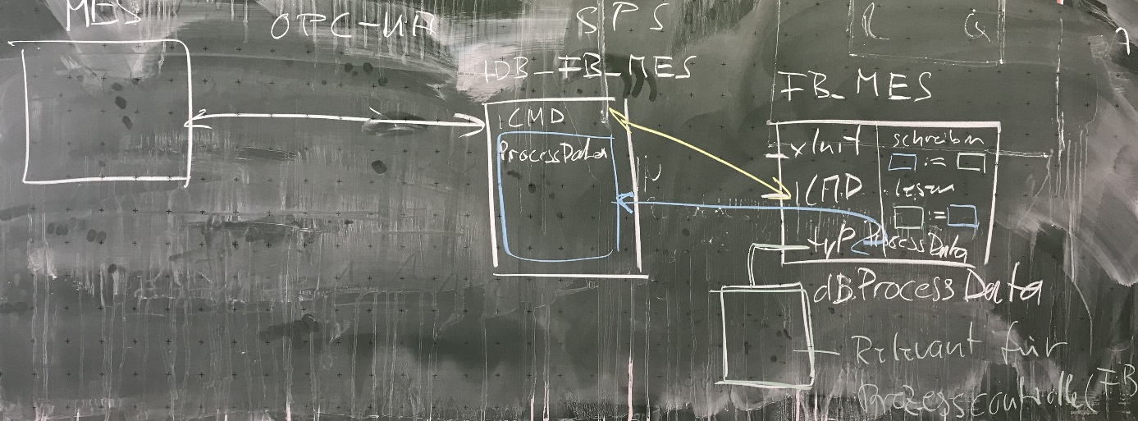

**-> goal**

**<Source**

**Source->**

**Target <-**

**<-?**

Illustration 1: "Developed" board image iCMD / communication between PLC <-> MES

All pictures (panel picture M. Lang / J. Schmider) are screen shoots from LFB module I431, LFB module I432 / © StD Raphael Hörner

************************************************** **************************************

# Communication flow

## Communication instructions

The exchange of information about which communication task (service) is requested by the PLC from the MES is usually implemented in communication technology using an integer command variable (iCmd).

Definition of iCmd:

* CMD_IDLE 0 Communication while idling, nothing to be done
* CMD_REQ 10 MES request, production data request
* CMD_RES 20th MES result, feedback of the completed production step

## Communication interface

The data exchange of the PLC <-> MES communication takes place via a TMES data structure. This contains both the command variable iCmd and the actual process data.

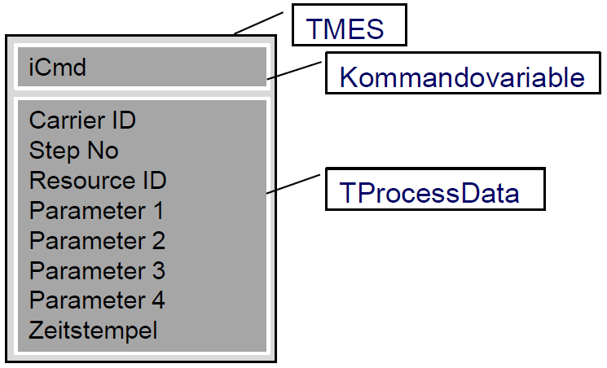[1]

Task:

Use the definition of iCMD to create a possible communication sequence between the PLC and

MES after the workpiece carrier has been identified by the PLC for the following cases:

1. Request for manufacturing parameters.
2. Confirmation of end of production.

Start on the PLC side, because after a carrier arrives, the PLC has to ask the MES what to do with the workpiece. Or has to inform the MES that the processing is finished.

To do this, add the following diagrams.

**Communication flow - Request manufacturing parameters**

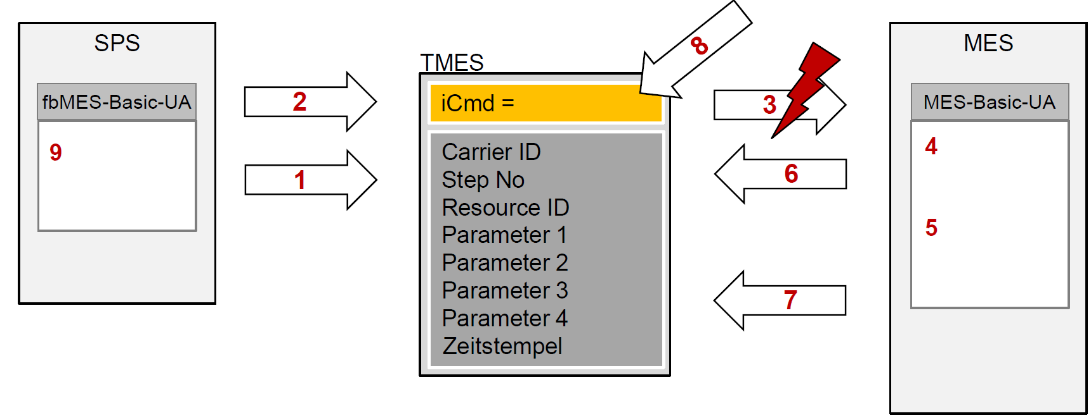[2]

A notice:

The arrow means an event that automatically triggers the OPC UA communication with the MES as soon as

the value of iCMD changes. This means that the MES does not have to constantly query the variable itself, but rather

just waiting for the event.

Assign the actions listed below to the number in the picture logically.

|  |  |
| --- | --- |
| 9 | The PLC evaluates the process data accordingly |
| 3 | Change to iCmd, triggers interrupt in MES |
| 1 | SPS writes the current CarrierID and ResourceID in TMES |
| 5 | MES checks the result set (result from DB query) to determine what to do |
| 2 | SPS sets iCmd to CMD_REQ |
| 7th | MES writes manufacturing parameters in TMES in case something needs to be done |
| 4th | MES carries out a DB query with CarrierID and ResourceID |
| 8th | MES resets iCmd to CMD_IDLE |
| 6th | MES writes the result of the action in StepNo (-1 = do nothing, otherwise production required) |

**Communication flow - Confirmation of the end of production by MES_RESULT**

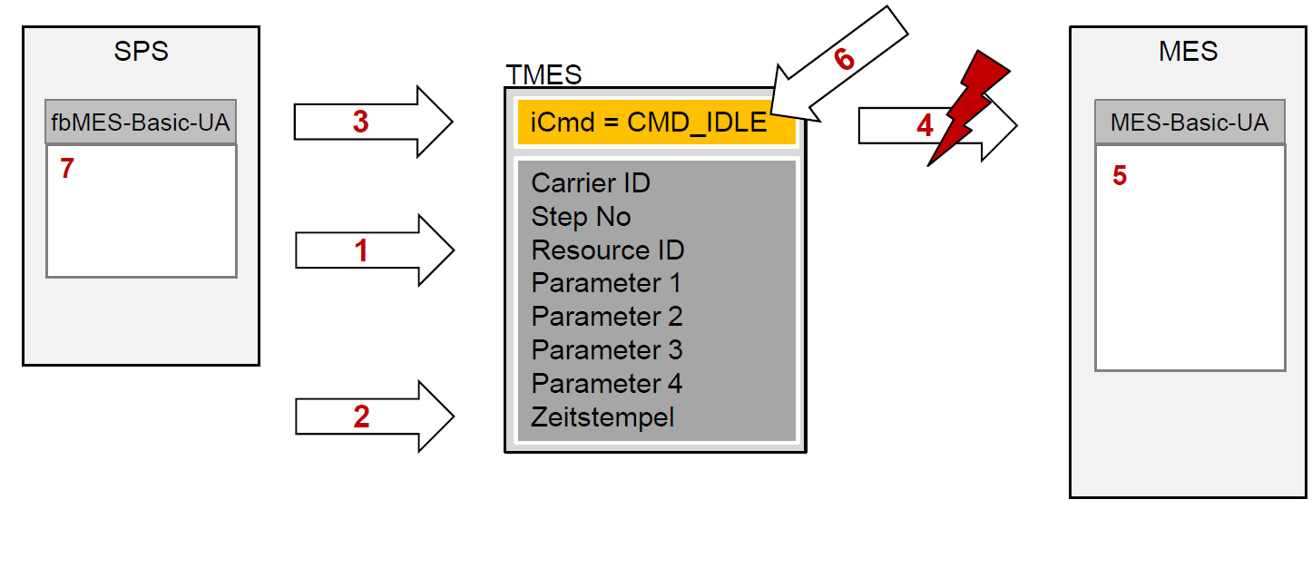[3]

A notice:

The arrow again means the event that automatically triggers the OPC UA communication in the MES

as soon as the value of iCMD changes.

Assign the actions listed below to the number in the picture logically.

|  |  |
| --- | --- |
| 4th | Change to iCmd, triggers interrupt in MES |
| 2 | The PLC determines the current time stamp and writes it to TMES |
| 5 | MES enters the time stamp in the corresponding data record via UPDATE |
| 6th | MES resets iCmd to CMD_IDLE |
| 3 | SPS sets iCmd to CMD_RES |
| 7th | PLC resets the process data |
| 1 | PLC updates process data in TMES |



"The European Commission support for the production of this publication does not constitute an endorsement of the contents which reflects the views only of the authors, and the Commission cannot be held responsible for any use which may be made of the information contained therein."

1. Source: Teacher training module I432 - Flyer Industry 4.0
2. Source: Teacher training module I432 - Flyer Industry 4.0
3. Source: Teacher training module I432 - Flyer Industry 4.0